IV. NOTES ON USE

- Use mild detergents for cleaning and disinfection. Do not use corrosive or abrasive products!
NOTE: Do not use agents containing naphtha, solvents, acids, chlorine etc. for cleaning soft surfaces!

- Product marking is performed in the form of an identification label attached to each device. The label contains the following information:
- number indicating the date of manufacture:
  - LOT: RRRR-MM ( RRRR means the year, MM means the month, e.g.: 2023-01)
- name and type of product e.g.: REF: 04/MR
- allowed body weight of the user

- All devices (except for caps) have a 2-year warranty.

- Use the devices as directed! Any bending of the metal parts with visible cracks on the surface exclude the device from further use.
Check the device before and during use to ensure that it has
no scratches, cracks, etc.

- The production service during the warranty period (24 months) includes replacement of parts or products, which are found to have any manufacturing defects.

- The MIKIRAD operational service functions directly at the points
of sale of the products.

- MIKIRAD guarantees the production of spare parts for 10 years from the date of manufacture of a product.
INSTRUCTIONS FOR USE
ELBOW CRUTCHES

MIKIRAD manufactures elbow crutches as medical devices for improving the mobility of people with disabilities (according to In-house Specification ZN-00/MK-01-2/2010 harmonised with standard PN-EN ISO 9999 – Class 12 03 and EUROPEAN COUNCIL DIRECTIVE 2017/745 [MDR] of 5 April 2017)

PN EN ISO 9999 | NAME | TYPE
12 03 06 | Elbow crutches:  - with double height adjustment, with mobile or fixed support  - with double height adjustment, with mobile lateral support  - with single height adjustment, for children  - with single height adjustment, with fixed support  - with single height adjustment, with mobile support  - with single height adjustment, with mobile lateral support | -01/MR, 02/MR,  -09/MR, 09/MR.E  -03/MR,  -04/MR, 04/MR.E  -05/MR, 05/MR.E  -08/MR, 08/MR.E

I. BACKGROUND

Standard products are designed for users (with lower limb disability or prostheses) with height of 155cm to 185cm and body weight of up to 130 kg, and in the case of pediatric crutches, for people with height of 130
to 155 cm and body weight of up to 80 kg.

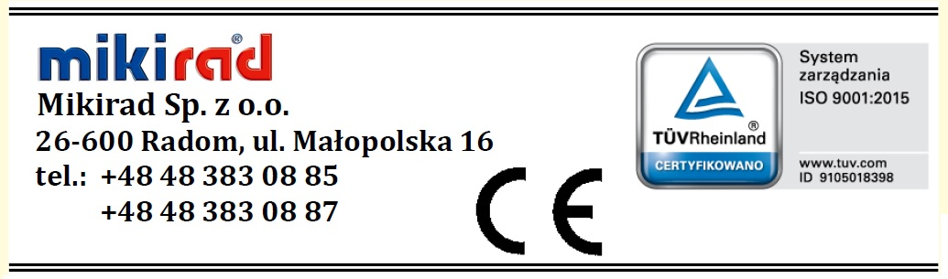 Each product is adapted to the user’s height by moving the interconnected telescopic rods to obtain the desired height, and then locking them. This is done by stepwise adjustment (sliding the adjustment rods from the shaft in increments of 20 mm and locking them with a latch fitted to the holes in the rods).

The height of a product is considered correct when the user has an upright posture when using the product, and the products works vertically, i.e. in the plane parallel to the body axis.

II. PROCEDURE FOR STEPWISE ADJUSTMENT
OF PRODUCT HEIGHT (Fig. 2)

- Push the double latch out of the holes by pushing both fronts of the latch wings towards the back using two thumbs, so as to move the wings and slide the steel pegs out of the rod holes.
Do not bend the latch wings as they may break or lose elasticity.

- Slide the adjustment rod along the axis to the appropriate height for the user; remember that the holes in the adjustment rod must ideally overlap the holes in the shaft.

- Insert the steel pegs of the latch into the correctly positioned holes and push the lath using your hand until the inside surface of the latch is in full contact with the rod shaft.

In winter, use an anti-slip winter cap, which is universal.

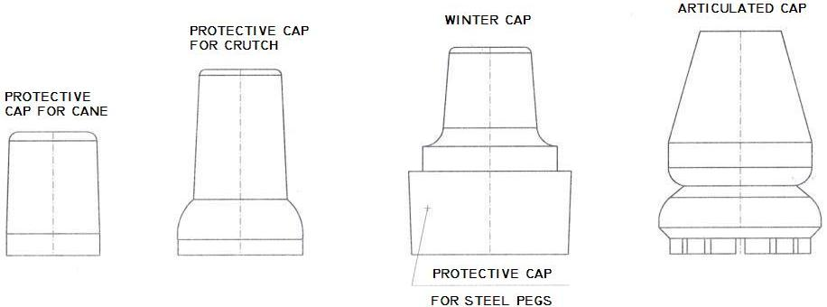

Fig.1 Protective cap

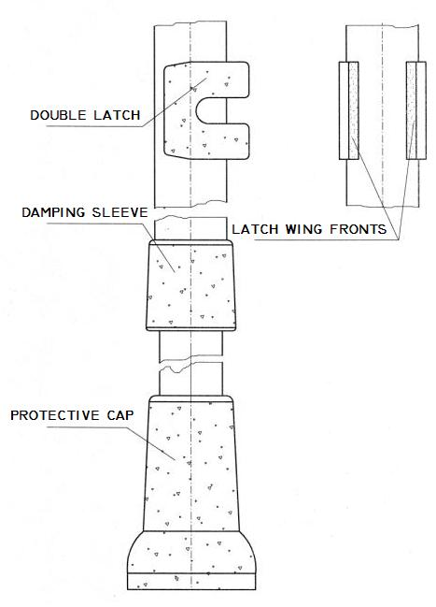

Fig.2 Stepwise adjustment

